GBIO Legislation Overview

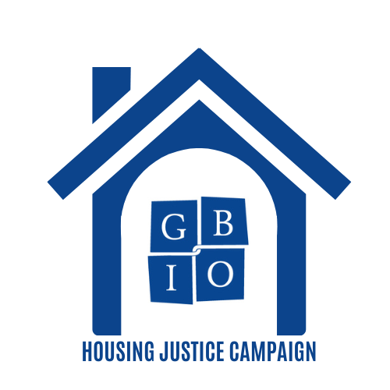
Housing Justice
GBIO’s multi-faceted, statewide Housing Justice Campaign focuses on public housing, affordable rental and homeownership opportunity, and housing access. We define Housing Justice as the ability for all people to have safe, healthy and clean homes in their communities, and so are seeking to improve housing access and quality for groups that have been unfairly denied it, and to support financing, zoning and ownership policies that help to close racial and class disparities in the housing market.

These campaigns all originate from the lived and recognized experiences in GBIO’s base of 60 member congregations and organizations, representing some 107,000 individuals in Massachusetts, and are centered in our commitment to promote racial and economic justice.

Campaign Asks
Safe and Dignified State Public Housing
- Approve $189 million in operating funds for Local Housing Authorities across the Commonwealth in the 2024 annual budget.
- Authorize through the 2023 five-year housing bond bill, at least $1.6 billion in capital funds, as has been included in the Governor’s housing bond bill proposal, called the Affordable Homes Act; and develop a plan to address the $8.5 billion capital needs in order to sustain public housing facilities and work off the accumulated backlog of deferred capital projects.

More Funding for Affordable Housing and Homeownership
- Pass statewide enabling legislation for a local option to collect real estate transfer fees
to increase funding for affordable housing, (H.2747/S.1771), and maintain real estate transfer fee legislation within the Governor’s housing bond bill, called the Affordable Homes Act.

Access to Quality Housing for Returning Citizens
- Approve $9 million for rental assistance for returning citizens through a $6 million increase to line item 7004-9034, “Housing Assistance for Re-Entry Transition,” which would provide first/last months’ rent, security deposit, and 1 year+ of rental assistance for returning citizens, administered by reentry nonprofits. (See fact sheet for more information.)
- Pass S.1506/H.2326 so that ALL Returning Citizens are guaranteed state IDs upon release.

Increasing Housing Supply
- Continue to use all available tools to fully implement the MBTA Communities Act and create more multifamily zoning, without penalizing housing authorities and their tenants.

Why these Asks?

Safe and Dignified State Public Housing
GBIO seeks to dramatically increase funding for operations, sustainable upkeep, and deferred maintenance in public housing. The lived experience of GBIO members in public housing tell us about the intolerable conditions they face every day. Our research reveals that for decades the State Legislature and Governor have failed to allocate anywhere near the funds needed for both healthy operations and the accumulating capital repairs required by the 43,000 units of state-funded public housing. Our asks reflect the true need of this valuable and essential Massachusetts asset.

Access to Quality Housing for Returning Citizens
GBIO is focused on promoting housing security by supporting vouchers for returning citizens, administered by returning citizen-led organizations like Justice 4 Housing. Stable housing is critical to ensuring public safety by reducing recidivism. Current costs to house an individual in prison are reaching $130k per year, and adequate housing would cost a fraction of that. Returning citizen-led organizations provide higher quality case management and are more likely to work with clients with respect and understanding for their life experiences than other programs. Equally important, housing entirely depends on the possession of a state ID or driver’s license, and a mandate to ensure that a state ID accompanies every Returning Citizen leaving incarceration is central to our work.

More Funding for Affordable Housing and Homeownership
GBIO seeks to bring new funds into local communities to be used for affordable rental housing and homeownership through passage by the legislature of the Real Estate Transfer Fee. This state legislation will allow municipalities to adopt a one-time, small fee on real estate sales over a certain transaction amount (e.g., $2 million), whose proceeds will go into that community’s affordable housing trust fund. These funds can be used for capital needs of new affordable housing projects, preservation of existing affordable housing properties, mortgage down payment support for first-time homebuyers, or rental subsidies for low-income households.

Increasing Housing Supply
GBIO will focus here on the implementation of the MBTA Communities Zoning Act to increase housing supply in local communities where GBIO has presence. This new law, passed in 2021, requires the 175 communities in central and eastern Massachusetts that are served by the MBTA’s subway and commuter rail systems to create new zoning districts in which multi-family housing is permitted near transit stations at densities that are higher than currently allowed but still reasonable in transit-oriented locations. This ask will most likely not be part of your IDM agenda, as it is a local, not state level action.

