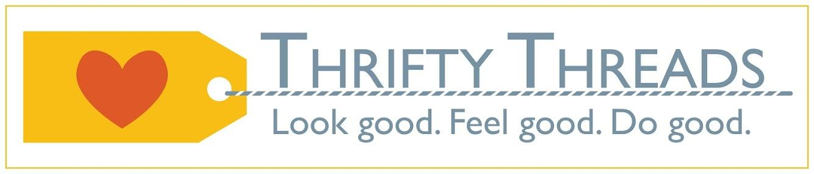

Welcome to Thrifty Threads Spring Fashion Showcase

Our coordinator/Director-
Ms. Lindy Lieberman recently joined Thrifty Threads w/ a background in design and interior decorating. Her eye for color, fashion and creativity leads us to the fashion show today.

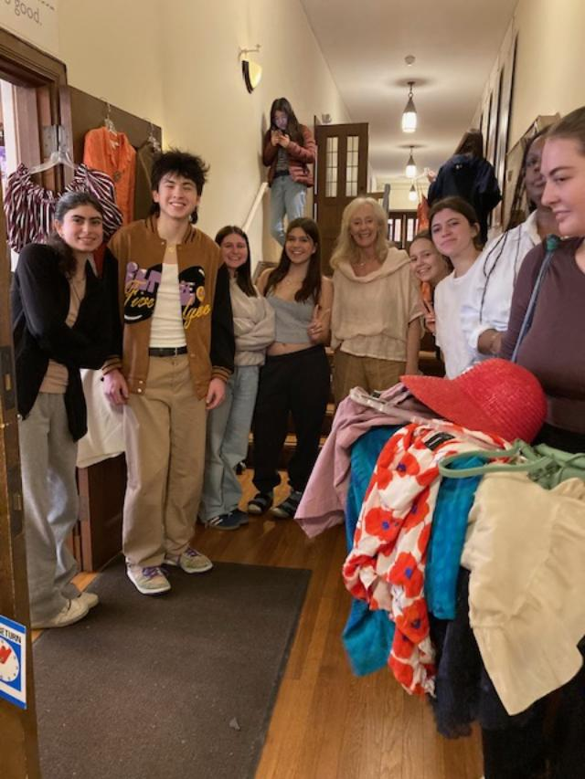

We have wonderful models

Music and sound are supported by Micah Deselms

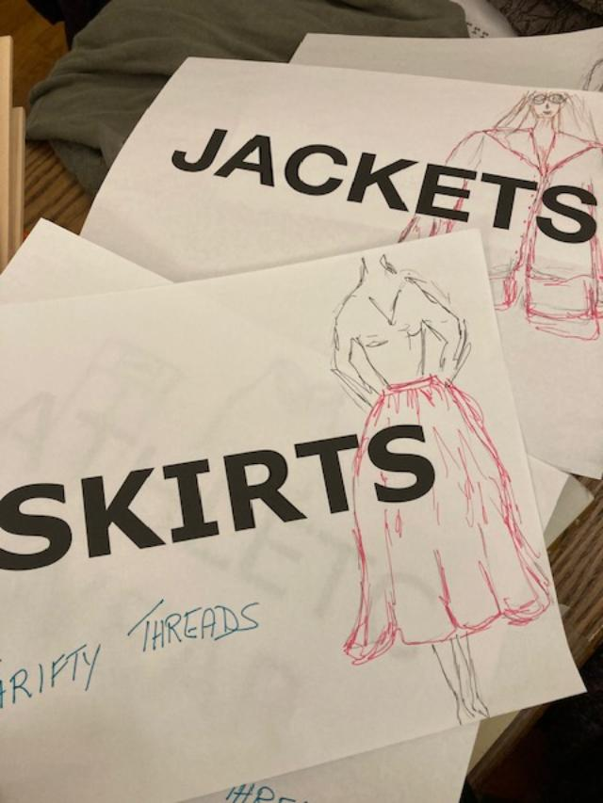
fashion prep is done by our dedicated fashion finders who are here to support the models in their hair, make up and fashion prep

When you visit Thrifty Threads, you will be assisted by our dedicated volunteers. We love what we do. Thanks to ALL our Volunteers helping today and every week.

Sexton-
Adam

Raffles prizes. Thank you to Brookline Book Smith, The Party Shop and Fran Beaumont. Please let these local businesses and people know you appreciate their donations.

Gifts

Crafts: Repair jewelry or use broken pieces with Hanna and Keren

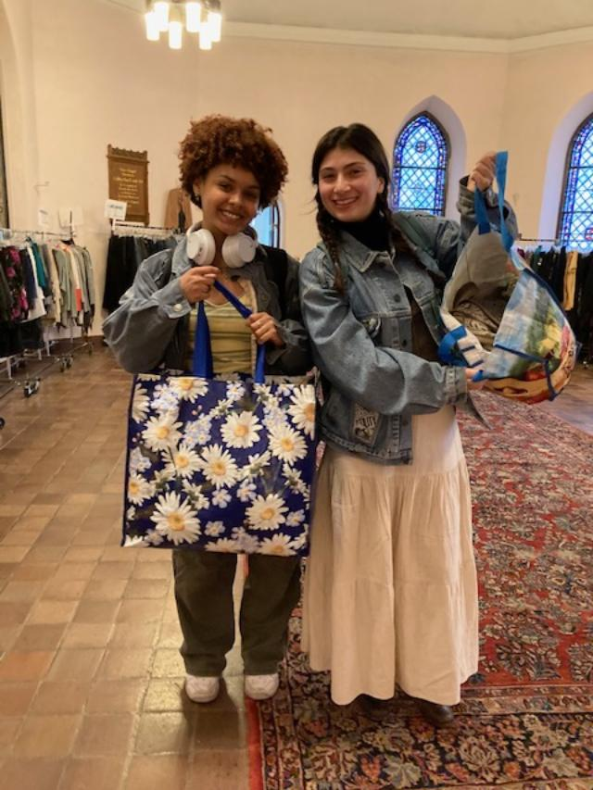
Learn to sew w/ Leianna, Linda and Gina
Learn to upcycle and use a sewing machine w/ Emma

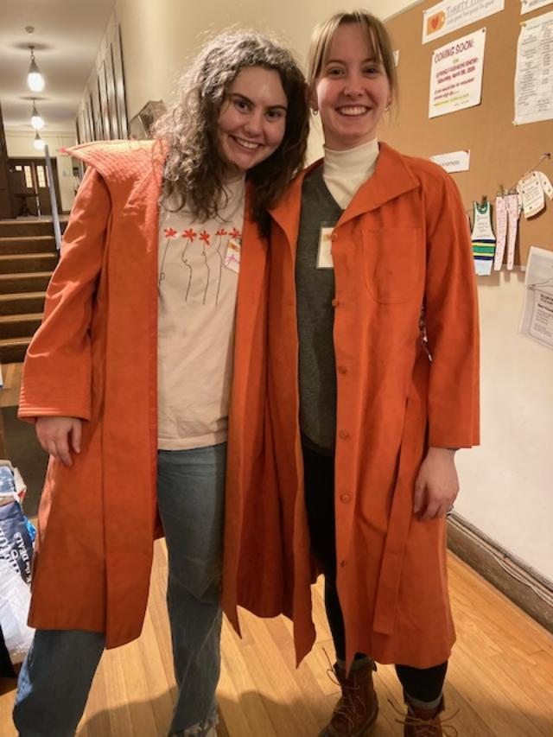
Welcome to Thrifty Threads.
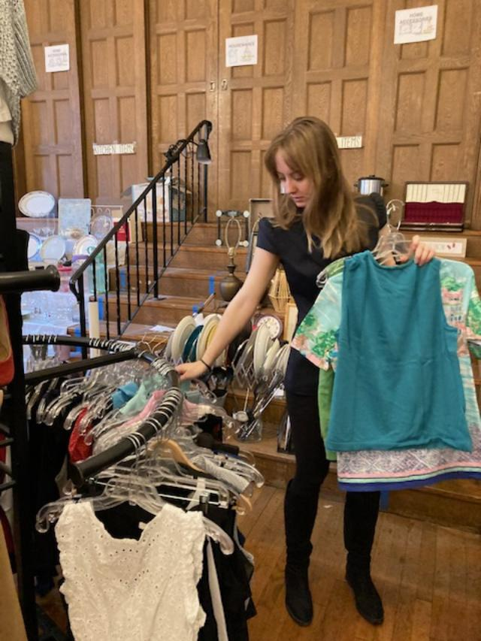

We are a donor-based inventory and staffed w/ volunteers. We are open Friday and Saturday 12-3.

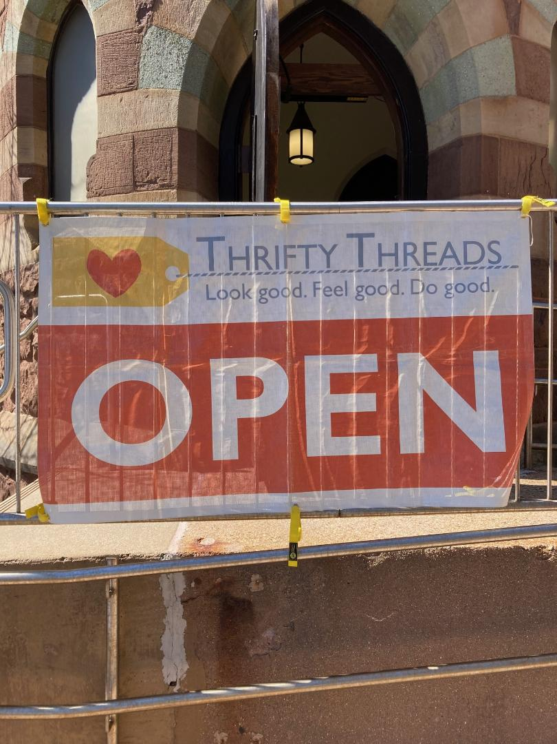

We provide clothing to many groups in need of clothing support. These include:
Second Chances
Solutions at Work in Cambridge
SPOT in Cambridge
Eastern Service Workers
Zion Cares Foster Closet
Cambridge Women’s Center
Transition House
Immigrant Families institute Society
Immigration groups
Special requests

We do not sell children’s clothing and donate it out to groups in need.

2024, we started our Kind Under Threads Program. We use some of the money we earn to pair new underwear and socks w/ the gently used clothing we provide.

March totals of donations going out:
March set a new record for donations out!
266 bags or 2,793 lbs or 1.4 tons of quality used clothing
Included in this number are 100 prom and fancy dresses (estimated to be 10 bags): 78 were donated to
the Cinderella Project in Maine; 22 were donated to the Belle of the Ball in Massachusetts
Also included are 22 bags to fulfil special requests, primarily for children

Thrift impact on environment: Learn More:

10 Concerning Fast Fashion Waste Statistics
CRISIS - POLLUTION CRISES BY MARTINA IGINIGLOBAL COMMONSAUG 21ST 20234 MINS
EARTH.ORG IS POWERED BY OVER 150 CONTRIBUTING WRITERS
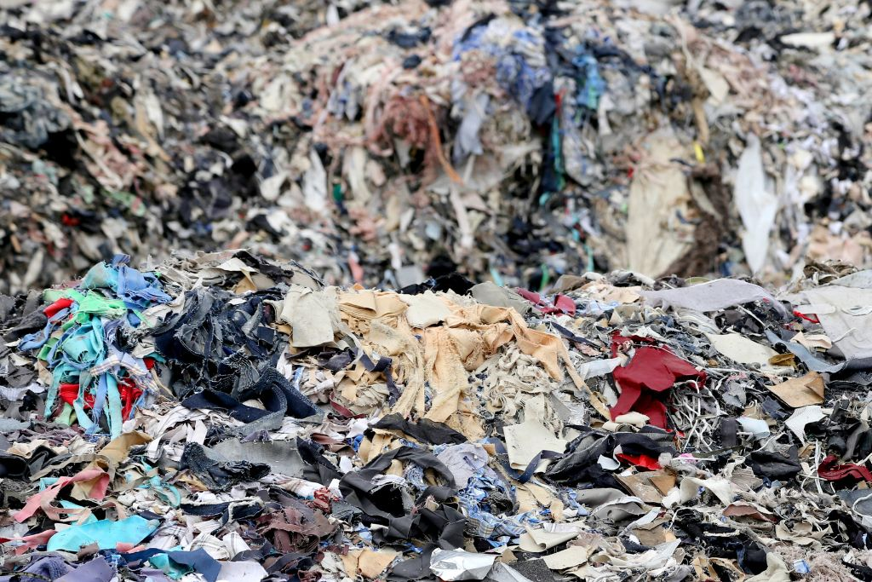
The extremely detrimental impact of fast fashion waste on the environment is no news. Besides being responsible for nearly 10% of global carbon emissions, the industry is also infamously known for the amount of resources it wastes and the millions of clothes ending up in landfills every day. Here are 10 highly concerning statistics about textile waste.
—

10 Statistics About Fast Fashion Waste

1. 92 million tonnes of textiles waste is produced every year
Of the 100 billion garments produced each year, 92 million tonnes end up in landfills. To put things in perspective, this means that the equivalent of a rubbish truck full of clothes ends up on landfill sites every second. If the trend continues, the number of fast fashion waste is expected to soar up to 134 million tonnes a year by the end of the decade.

2. The apparel industry’s global emissions will increase by 50% by 2030
If a business-as-usual scenario prevails in the coming years – meaning that no action is taken to reduce fast fashion waste – the industry’s global emissions will likely double by the end of the decade.
Invest in a Sustainable FutureBy supporting Earth.Org, you are investing in a sustainable future for our planet. Help us drive positive change by contributing to our ongoing efforts to protect the environment.
DONATE NOW

3. The average US consumer throws away 81.5lbs of clothes every year
In America alone, an estimated 11.3 million tons of textile waste – equivalent to 85% of all textiles – end up in landfills on a yearly basis. That’s equivalent to approximately 81.5 pounds (37 kilograms) per person per year and around 2,150 pieces per second countrywide.

4. The number of times a garment is worn has declined by around 36% in 15 years
The throwaway culture has worsen progressively over the years. At present, many items are worn only seven to ten times before being tossed. That’s a decline of more than 35% in just 15 years.
Photo by EO Photographer Chin Leong Teo.

5. The fashion industry is responsible for 20% of global waste water
Dyeing and finishing – the processes by which colour and other chemicals are applied to fabrics – are responsible for 3% of global CO2 emissions as well as over 20% of global water pollution. Along with yarn preparation and fibre production, these two processes have the highest impacts on resource depletion, due to the energy-intensive processes based on fossil fuel energy.

6. It takes 20,000 litres of water to produce one kilogram of cotton
Besides being a huge source of water pollution, fast fashion also contributes to massive quantities of water being wasted every day. If this is difficult to picture, just think that about 2,700 litres of water are needed to make just one t-shirt, which would be enough for one person to drink for 900 days. Moreover, a single load of washing uses between 50 and 60 litres of water.

7. $500 billion is lost each year because of under-wearing and failure to recycle clothes
The worst aspect of our reckless thrown-away culture is that the vast majority of clothes being tossed each year is not recycled. Globally, just 12% of the material used for clothing ends up being recycled. Much of the problem comes down to the materials our clothes are made from and inadequate technologies to recycle them. “The fabrics we drape over our bodies are complex combinations of fibres, fixtures and accessories. They are made from problematic blends of natural yarns, man-made filaments, plastics and metals.”
You might also like: Is Hong Kong’s Avant-Garde Textile Recycling Facility a Real Solution to Fast Fashion Problems?

8. Nearly 10% of microplastics dispersed in the ocean each year come from textiles
Garments are a huge source of microplastics because so many are now made of nylon or polyester, both durable and cheap. Each wash and dry cycle, especially the latter, sheds microfilaments that move through our sewage systems and end up in waterways. It is estimated that half a million tons of these contaminants reach the ocean each year. That’s the equivalent to the plastic pollution of more than 50 billion bottles.

9. 2.6 million tonnes of returned clothes ended up in landfills in 2020 in the US alone
Most of the items returned to retailers from consumers end up in landfill. This is mainly because it costs more to the company to put them back in circulation than to get rid of them. Reverse logistics company Optoro also estimates that in the same year, 16 million tonnes of CO2 emissions were created by online returns in the US in 2020 – the equivalent to the emissions of 3.5 million cars on the road for a year.
You might also like: Fast Fashion and Its Environmental Impact

10. Fast fashion brands are producing twice the amount of clothes today than in 2000
This dramatic increase in production has also caused an increase in both pre- and post-production textile waste. Due to the number of cut outs for the clothing, a large number of materials get wasted as they cannot be used any further, with one study estimating that 15% of fabric used in garment manufacturing is wasted. Post-production, 60% of approximately 150 million garments produced globally in 2012 were discarded just a few years after production.
Research for this article was conducted by Earth.Org research contributor Chloe Lam
TAGGED: FAST FASHION

Instagram: Thriftythreads_Brookline

We love your support.
We can accept your donations Tuesday-Fri 10-5 and Saturday 12-3
We invite you back to shop during store hours Fri and Sat 12-3
We welcome your questions at Thriftythreads@upbrookline.org

Thank you for being here with us. We are going to do better by working together, making each other happy by creating something positive that helps others!

