2025 Missions Giving Christmas Market

Love is our light

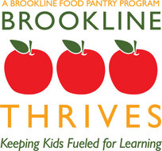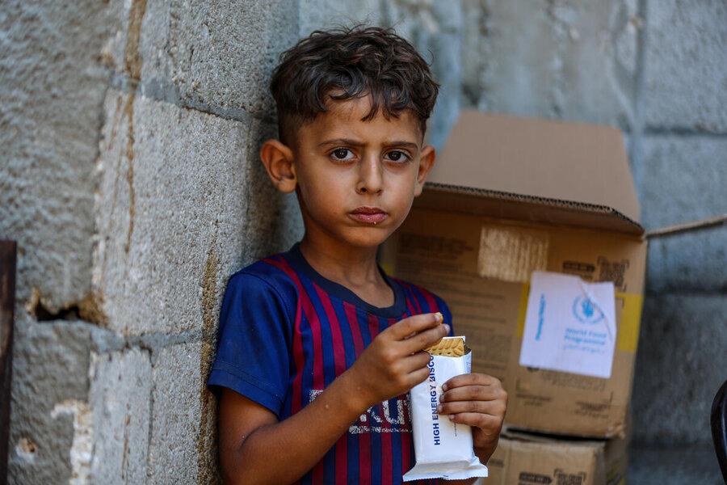

Brookline Food Pantry World Food Program - Gaza

The Missions Giving Ministry Team will MATCH
donations to these organizations.

- Give online: unitedparishbrookline.org/give
- Or mail one check and form to the United Parish office.
- United Parish will MATCH and distribute donations.

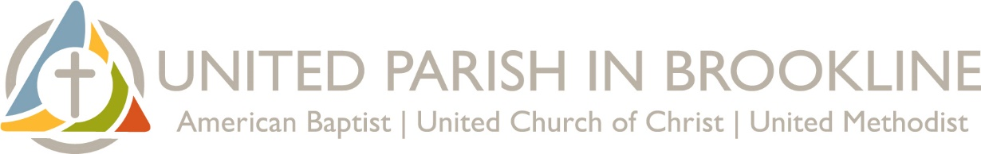

We support the power of GOOD!

The 8 organizations in this brochure are helping
locally, nationally, or internationally.

“Act as if what you do makes a difference.
It does.”

— William James

In the past, youth from Church School recommended an organization. This year they said, “All are important.”

Let love be our light!

Agape Global Health for Haiti
Because the small Haitian island of La Gonave, is where Agape Global Health is located, is a haven to escape the violence in Port-au-Prance, Agape facing an influx of displaced people. The numbers of people in need of medical services keep growing.

Agape brings hope through:

- The Agape Clinic
  - A health clinic specializing in prenatal and newborn care.

- Menstrual health education
  - Teaching girls and women about their bodies and menstruation.
  - Providing washable, reusable menstrual kits empowering girls to stay in school when they’re menstruating.

- Clean water access
  - Training and equipping women to clean water using high-efficiency filtration systems to supply safe drinking water to families.

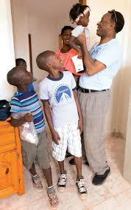

Doctors from the Boston medical community – including a parishioner from United Parish in Brookline – have visited Agape Global Health in the past and continue to consult.

Gift #1: Agape Global Health for Haiti
Brookline Food Pantry
None of our neighbors should go to bed hungry.
Every week, the Brookline Food Pantry provides food to over 700 households — families with young children, elders on fixed incomes, new arrivals to our community, and longtime neighbors facing unexpected hardship. The need keeps growing. Especially in the face of today’s government cuts.
They also prepare weekend meal packs for local students who rely on school meals during the week, and deliver food to Brookline residents who are elderly or ill and can’t come to the Brookline Food Pantry themselves.
For years, United Parish has stood alongside the Brookline Food Pantry through food drives, the Walk for Hunger, and financial support.
In this moment of rising need, food matters more than ever.

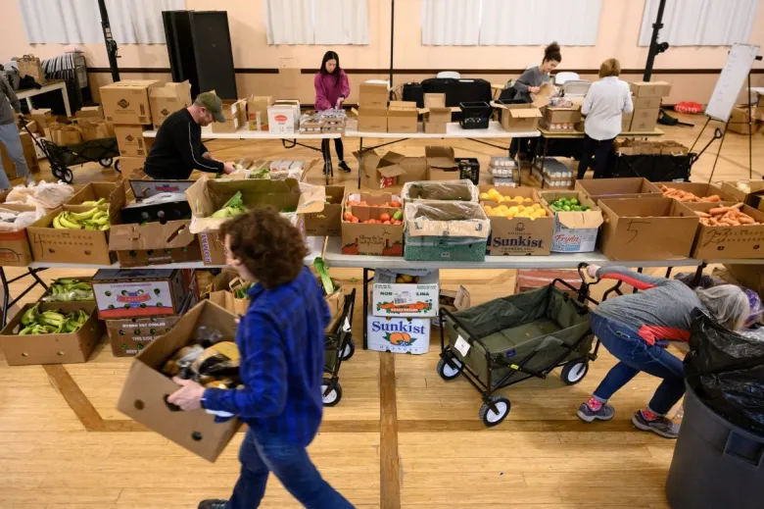

Contact brooklinefoodpantry@gmail.com to volunteer throughout the year.

Gift #2: Brookline Food Pantry
Dhansa Maweni School, Kenya
Many families simply cannot afford the fees required for public school. The Dhansa Maweni School opens its doors to children ages three to fourteen, offering a place to learn, to grow, and to dream.
Four devoted teachers and one maintenance worker keep the school running, teaching everything from math and science to English, Swahili, creative arts, and Christian religious education. They also make sure children receive breakfast porridge — sometimes the only dependable meal of the day.
Love and steady support is a lifeline — helping children break free from poverty and build a future filled with promise. This little school creates ripples of opportunity that can help lift children — and their families — out of poverty.

- $25 pays one week of a teacher’s salary.
- $50 provides one year of a student’s school supplies.
- $100 provides one month of breakfast porridge.

A United Parish in Brookline congregant visits the school every year to witness the inspiring children and the stellar work of the staff.

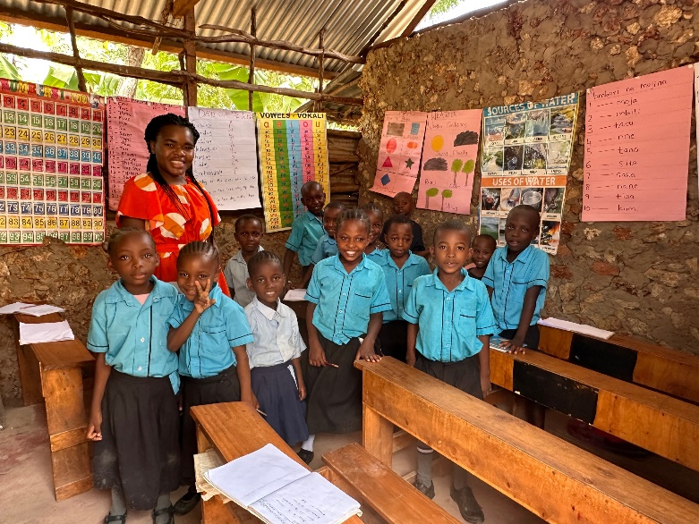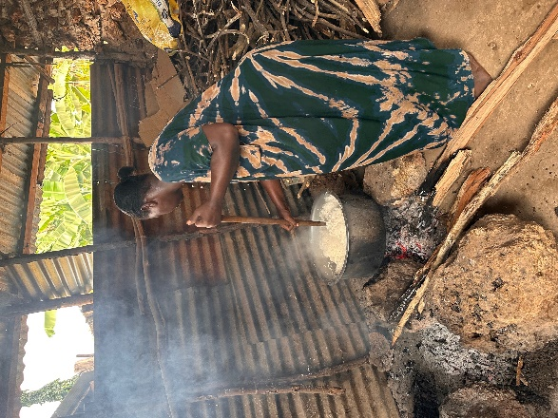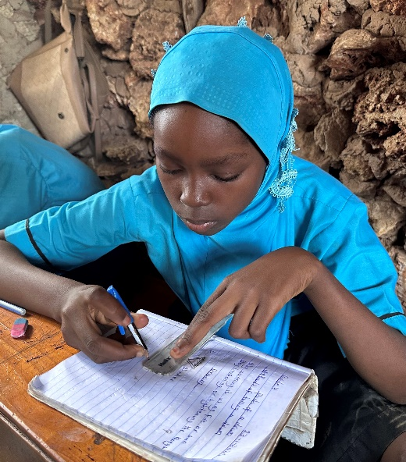

Education is the premise of progress, in every society, in every family.
– Kofi Annan, former secretary general of the United Nations

Gift #3: Dhansa Maweni School, Kenya
Environmental League of Massachusetts (ELM)
The Environmental League of Massachusetts works to protect the air we breathe, the water we depend on, and the climate our communities need to thrive. They push for bold state policies that accelerate clean energy, modernize transportation, and ensure that environmental benefits reach every neighborhood.
ELM focuses on high-impact solutions:
- Expanding renewable energy,
- Strengthening protections for forests and wetlands,
- Improving public transit,
- Reducing building emissions, and
- Holding state leaders accountable to Massachusetts’ climate commitments.

Their work helps shape the long-term systems that determine whether our communities will be healthy, just, and resilient for generations to come. Since its founding in 1898, ELM has been instrumental in landmark environmental protections.
By supporting ELM, we help move Massachusetts toward a healthier, more just, and more resilient future for everyone who calls this place home.
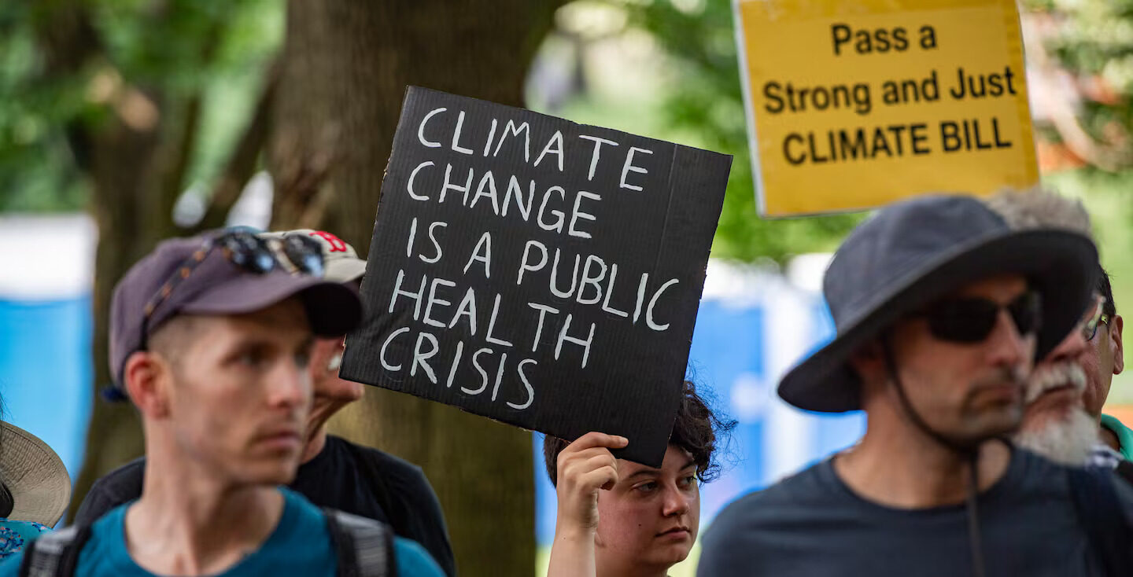
Gift #4: Environmental League of Massachusetts

Horizons for Homeless Children

At no Christmas – at no time ever – should a child be homeless.

Horizons for Homeless Children leads the fight in Massachusetts to help alleviate the trauma and stress of homelessness on both children and their families. They provide high-quality early education, opportunities for play (so important), support for parents, and crucial advocacy on behalf of our neighbors going through tough times.

Support for Horizons for Homeless Children provides essential:

- Early education
- Help & Support for Parents
- Play in Shelter
- Advocacy
Combating the effects of homelessness becomes an even more pressing and critical mission when children are involved.

Invest in a child’s future.

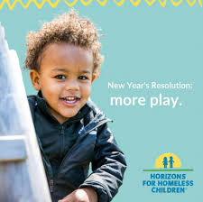

Gift #5: Horizons for Homeless Children
International Institute of New England (IINE)
Some leaders are slamming the doors on immigration. Others know that with newcomers, our cities, states and country grow stronger – that’s fundamental to the American story.
The International Institute of New England helps refugees and immigrants build safe, stable, self-sufficient lives in Boston and New England after surviving war, persecution, disaster, or displacement.
From the moment families arrive, IINE provides:
- Housing support
- English classes
- Job training
- Legal assistance
- Help navigating schools and healthcare
The work of IINE is practical and immediate: getting people settled, connected, and ready to thrive in a new home. Each year, they support thousands of newcomers rebuilding their lives after war, persecution, or disaster.
As Axios reported this fall, IINE has already lost more than $10 million in federal support. Yet IINE continues to welcome and support thousands of newcomers because, as they note, the need is growing — not shrinking.

Gift #6: International Institute of New England

Native Land Conservancy
The Native Land Conservancy is the first Native-run land trust east of the Mississippi. Dedicated to protecting and restoring land in the homelands of the Wampanoag and Massachusett peoples, they work to conserve forests, rivers, and shorelines while also preserving access for cultural, educational, and ecological purposes.
Their approach is rooted in Indigenous stewardship — caring for the land in ways that sustain both the environment and the communities connected to it. By returning land to Native care and protecting it for future generations, they model a powerful form of healing and justice.
Support for the Native Land Conservancy strengthens Indigenous leadership and helps safeguard the land we all depend on.
Honor the land by supporting those who have long protected it.

History is complicated. United Parish in Brookline stands on land once stewarded by the Massachusett indigenous people. Our Congregational and Methodist ancestors supported brutal boarding schools that sought to erase Native identity. We can’t change history, but we can respond with honesty, respect, and action today.

Gift #7: Native Land Conservancy

World Food Program (WFP)
The United Nations World Food Program is the world’s largest humanitarian organization focused on ending hunger, providing food and nutrition support to people affected by conflict, disaster, and poverty in more than 120 countries.
Alongside emergency response, WFP partners with communities through school meals, nutrition programs, and climate-resilient food initiatives.
Global hunger is rising as war, displacement, economic instability, and climate-driven disasters push millions to the edge. WFP prioritizes those hardest to reach, especially children and families cut off from stable food access.
Today, they are leading lifesaving emergency relief in several crises, including Gaza, where access to food and clean water is critically limited.

World Food Program, winner of the 2020 Nobel Peace Prize

Gift #8: World Food Program

United Parish in Brookline
Missions Giving

United Parish Missions Giving is committed to financially supporting organizations doing good work locally, nationally and internationally.
Funds come from three sources:
- Interest from the United Parish church endowment
- Roughly 10% of all pledges to United Parish goes to Missions Giving and other philanthropic efforts
- Specific offerings in church services
Missions Giving also supplements, matches, doubles or triples the amounts raised by congregants involved in church-sponsored initiatives, such as the Negro Spiritual Royalties Project and Walk for Hunger.

“Where your treasure is, your heart will be also.”

– Matthew 6:21

The world needs the light of love more than ever.

Let’s be the light!

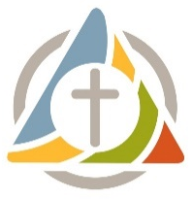
United Parish in Brookline
Missions Giving Christmas Market 2025

 | Organization | Dollar Amount
Gift #1 | Agape Global Health for Haiti
Gift #2 | Brookline Food Pantry
Gift #3 | Dhansa Maweni School, Kenya
Gift #4 | Environmental League of Massachusetts
Gift #5 | Horizons for Homeless Children
Gift #6 | International Institute of New England
Gift #7 | Native Land Conservancy
Gift #8 | World Food Program
Additional Donation to Missions Giving
Grand Total

(To fill out the above form online, please click here or scan the QR code.)

- Give online at unitedparishbrookline.org/give.
  - Enter the amount, and select “Missions Giving Christmas Market” from the Fund dropdown menu.
- Or mail one check and form to the United Parish office.

United Parish will match and distribute donations.

Name ___________________________________


Email ____________________________________

I/we plan to donate via:
____ Cash

____ Online at unitedparishbrookline.org/give
____ Check (Payable to United Parish in Brookline.
Memo: Missions Giving Christmas Market)
____ Venmo (Search @unitedparishinbrookline on the app, or scan the QR code)
____ PayPal (Click here or scan the QR code)

